Trip to Paris

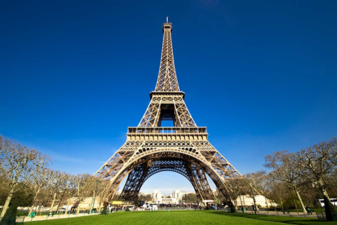

Summer Vacation

Whether you're looking for a romantic getaway or hoping to explore one of Europe's most popular destinations, Paris offers the best of both worlds. Explore the city's maze of fascinating historical sights - lose yourself in the world-famous Louvre, see the splendour of Versailles, and make your mark at the Moulin Rouge.

June 17, 2014

Hotel Da Vinci

www.TripAdvisor.com